User HomePage : This is the user Home Page .

Login Page : This is the Login Page where users needs to login in to the application. 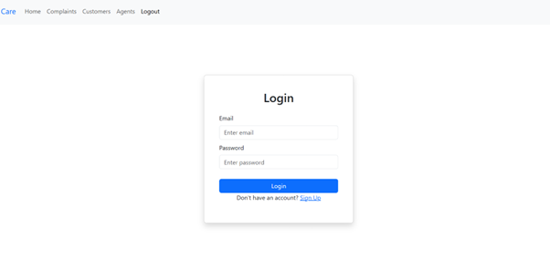
Register Page : This is the Register Page where users needs to sign up to the application. 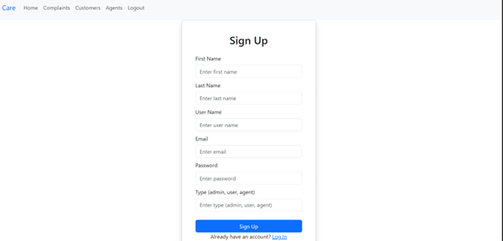
Complaints Page : This is the complaints Page where users needs to Lodge a complaint 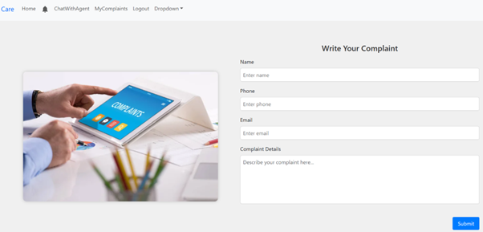
My Complaints Page : This is the my complaints page where users can check there registered complaints